**System Requirement Specification (SRS)**

**Of**

**Online Product Delivery system**

**Technical Story Card**

**Revision History**

|  |  |  |  |
| --- | --- | --- | --- |
| Version No. | Date | Prepared by | Significant Changes |
| 1 | 23/10/21 | Kuriseti.Krishna Sujith |  |
| 2 | 23/10/21 | Mungara.Gowthami |  |
| 3 | 23/10/21 | Navin.B |  |
| 4 | 23/10/21 | RamKumar.S |  |
| 5 | 23/10/21 | Niranjan Kumar |  |

**Glossary**

|  |  |
| --- | --- |
| Abbreviation | Description |
| OPDS | Online Product Delivery System |
| SRS | Software Requirement Specification |
| GUI | Graphical User Interface |

**Table of Contents**

**1. Introduction………………………………………………………………………..4**

1.1 Purpose …………………………………………………………………………………..4

1.2 Scope ………………………………………………………………………………...….4

1.3 overview………………………………………………………………………………......4

**2. Overall Description……………………………………………………………….4**

2.1 Product Description……………………………………………………………………...4

2.2 Product Functions………………………………………………………………………..5

2.3 User Characteristics…………………………………………………………………......5

2.4 Principal Actors………………………………………………………………………..….5

2.5 General constraints……………………………………………………………………....5

2.6 Assumptions and Dependencies…………………………………………………….....5

**3. Specific Requirements…………………………………………………………….5**

3.1 Functional Requirements………………………………………………………………...5

3.1.1 Registration………………………………………………………………………………………………....5

3.1.2 Login…………………………………………………………………………………………...…….……...6

3.1.3 Changes to cart………………………………………………………………………………………….....6

3.1.4 Payment……………………………………………………………………………………………………..6

3.1.5 logout………………………………………………………………………………………………………...6

3.1.6 Report Generation………………………………………………………………………………………….6

3.2 Non-Functional requirements……………………………………………………..……...7

3.3Performance Requirements……………………………………………………………….7

3.4Technical Issues…………………………………………………………………………….7

**4.Interface……………………………………………………………………….……...7**

4.1Requirements…………………………………………………………………………..…..7

4.2 Software Interface…………………………………………………………………..…….8

4.3 Hardware Interface………………………………………………………………..….…..8

4.4 Communication Interface………………………………………………………..……….8

**5. Operational Scenario……………………………………………………………....8**

**6. Preliminary schedule……………………………………………………………....9**

6.1 Block Diagram……………………………………………………………………………..10

**Online Product Delivery System**

**1. Introduction**

**1.1 Purpose:**

This document is meant to delineate the features of OPDS, so as to serve as a guide to the developers on one hand and a software validation document for the prospective client on the other. The Online Product Delivery System(OPDS) for electronics item shop web application is intended to provide complete solutions for vendors as well as customers through a single get way using the internet.It will enable vendors to setup online shops, customer to browse through the shop and purchase them online without having to visit the shop physically. The administration module will enable a system administrator to approve and reject requests for new shops and maintain various lists of shop categories.

**1.2 Scope:**

This system allows the customer’s to maintain their cart for adding or removing the product over the internet.

**1.3 Overview:**

This system provides an easy solution for customers to buy the product without going to the shop and also for the shop owner to sell the product. This proposed system can be used by any naïve users and it does not require any educational level,experience or technical expertise in the computer field but it will be of good use if the user has the good knowledge of how to operate a computer.

**2. Overall Description:**

The Online Product Delivery System(OPDS) application enables vendors to set up online shops, customers to browse through the shops, and a system administrator to approve and reject requests for new shops and maintain lists of shop categories. Also the developer is designing an online shopping site to manage the items in the shop and also help customers to purchase them online without visiting the shop physically.The online shopping system will use the internet as the sole method for selling goods to its consumers.

**2.1 Product Perspective:**

This product is aimed toward a person who doesn't want to visit the shop as he might don’t get time for that or might not be interested in visiting there and dealing with a lot of formalities.

**2.2 Product Functions:**

OPDS should support this use case

**2.3 User Characteristics:**

Users should be familiar with the terms like login,register,order system etc.

**2.4 Principle Actors:**

2 Principle Actors are Customer and Administrator.

**2.5 General Constraints:**

A full internet connection is required for OPDS.

**2.6 Assumptions and Dependencies:**

Working of OPDS needs Internet Connection.

**3.Specific Requirements:**

**3.1 Functional Requirements:**

* This section provides a requirement overview of the system.
* Various functional modules that can be implemented by the system will be -

**3.1.1 Registration**

A customer wants to buy the product then he/she must be registered,unregistered users can’t go to the shopping cart.

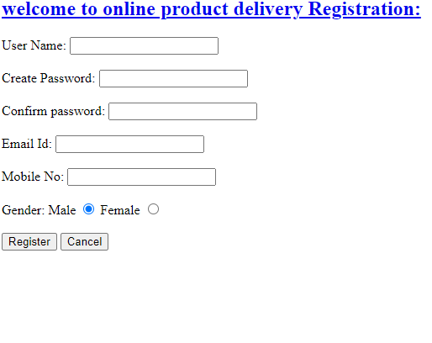

**3.1.2 Login**

Customer logins to the system by entering valid user id and password for the shopping.

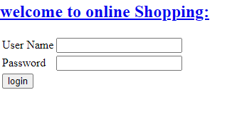

**3.1.3 Changes to cart**

Changes to cart means the customer after login or registration can make an order or cancel the order of the product from the shopping cart

.

**3.1.4 Payment**

In this system we are dealing with the mode of payment by cash. We will extend this to credit card ,debit card etc in the future.

**3.1.5 Logout**

After ordering or surfing for the product customer to logout.

**3.1.6 Report Generation**

After ordering for the product, the system will send one copy of the bill to the customer’s Email-address and another one for the system database.

**3.2 Non-Functional Requirements:**

Following Non-Functional Requirements will be there in the insurance to the internet:

1. Secure access to consumer’s confidential data.
2. 24X7 availability.
3. Better component design to get better performance at peak time.
4. Flexible service based architecture will be highly desirable for future extension.
5. Non-Functional Requirements define system properties and constraints. Various other Non-Functional Requirements are:

* Security
* Reliability
* Maintainability
* Portability
* Extensibility
* Reusability
* Compatibility
* Resource Utilization

**3.3 Performance Requirements:**

(i) In order to maintain an acceptable speed at maximum number of uploads allowed from a particular customer as any number of users can access the system at any time.

(ii) Also the connections to the servers will be based on the attributes of the user like his location and server will be working 24X7 times.

**3.4 Technical Issues:**

This system will work on client-server architecture. It will require an internet server which will be able to run PHP applications. The system should support some commonly used browsers such as IE, Mozilla Firefox, chrome etc

**4 . Interface**

**4.1 Requirements:**

Various interfaces for the product could be-

1). Login Page.

2). Registration Form.

3). There will be a screen displaying information about products that the shop has.

4). If the customers select the buy button then another screen of shopping cart will be

Opened.

5).Then it will ask for the customer's address and then it will go to the payment page.

6).Then in this payment page it will show the payment options and after selecting the

payment option it will redirect to the payment page.

7). Then after ordering for the product,the system will sent one copy of the bill to the

Customer email address.

8).Here we can also see the status of the delivery.

**4.2 Software Interface:**

1.Operating System:Windows7 Ultimate which supports networking.

2.JAVA development toolkit.

**4.3 Hardware Interface:**

Hardware requirements for insurance on internet

will be same for both parties which are as follows:

Processor:Dual Core

RAM:2 GB

Hard Disk:320 GB

NIC:For each party

**4.4 Communication Interfaces:**

The two parties should be connected by LAN or WAN for the communication purpose.



Communication

SENDER RECEIVER

# **5.** **Operational Scenario:**

* The customer wants to buy an item. The system shows all product categories to customers. If a customer selects an item then they are listed in the shopping cart for buying.
* The payment will be made with a credit card or bank check. If a customer wants to cancel the order before shipping then he or she can cancel it.
* Customers can see the buying report on account details.

**6.Use Case Diagram:**

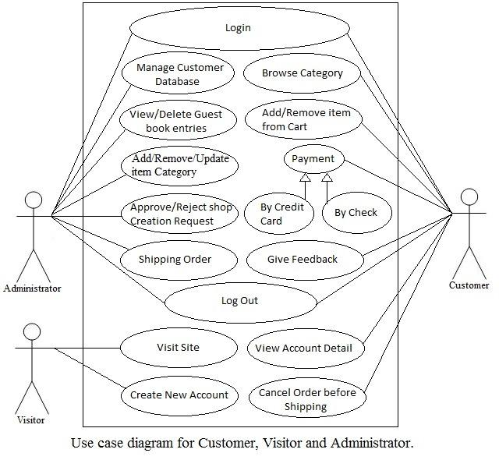

**6.1 Block Diagram:**

